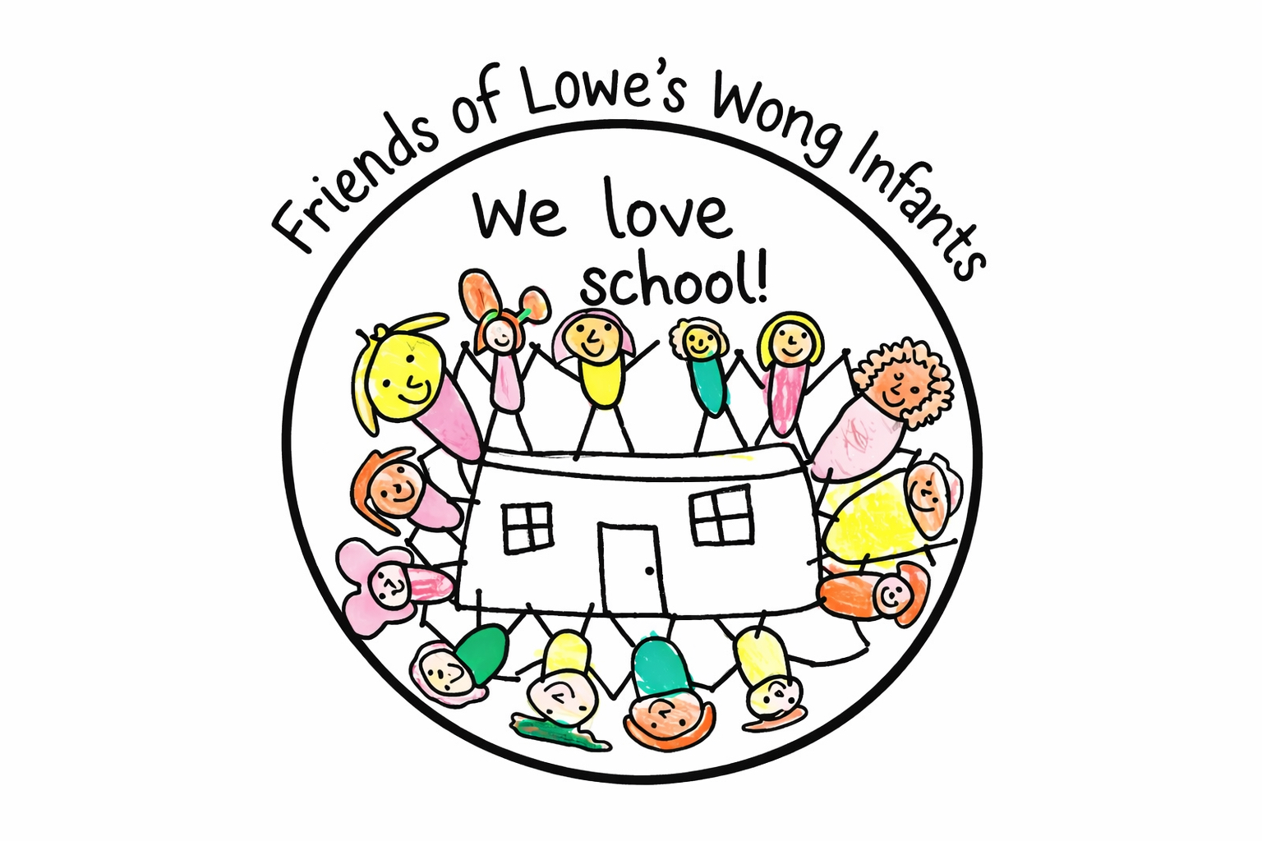
NEW SCHOOL UNIFORM
PRICE LIST
UNIFORM ITEM | PRICE
Branded Polo | £8.00
Branded Polo Age 9/10 and 11/12 | £9.00
Branded Cardigan | £14.00
Branded Cardigan Age 9/10 and 11/12 | £15.00
Branded Jumper | £12.00
Branded Cardigan Age 9/10 and 11/12 | £13.00
Book Bag | £5.00

PRE-LOVED SCHOOL UNIFORM IS ALSO AVAILABE FROM THE OFFICE
– ALL ITEMS ARE 50p.

Thank you for supporting Friends of Lowe’s Wong Infants! ❤️

Every purchase helps us support our school and our children.

